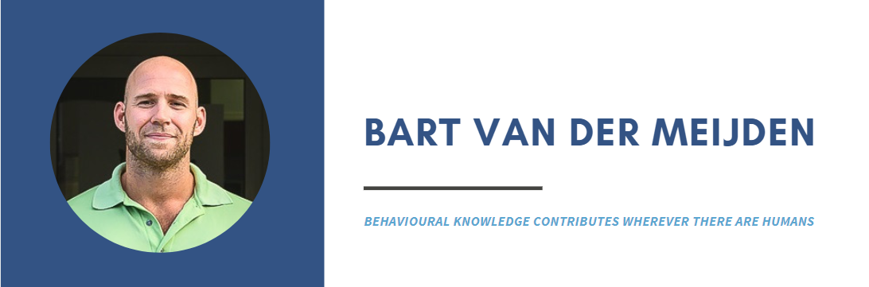
My name is Bart van der Meijden, born and raised in the Netherlands. I studied physical education in The Hague and Social Psychology in Utrecht. After receiving my Master’s degree in 2018, I moved to Sint Maarten to live with my girlfriend who I met whilst traveling in South East Asia.
I began to work at the Mental Health Foundation as Information & Prevention Coordinator right away. Within this function, I aimed to inform and educate the general population about mental health and the foundation’s services, and thereby reducing the stigma on mental health. Some projects that I am proud of are the Destigmatizing Video project in 2019 and organizing the Happiness Event in 2020.
After a sailing trip to Iceland and Greenland last summer, I started at the White and Yellow Cross Care Foundation as Communication Coordinator, where I am currently working on a promotional campaign for the Covid-19 vaccines.
In my free time, I love to travel and do various outdoor sports like surfing and triathlons.

